
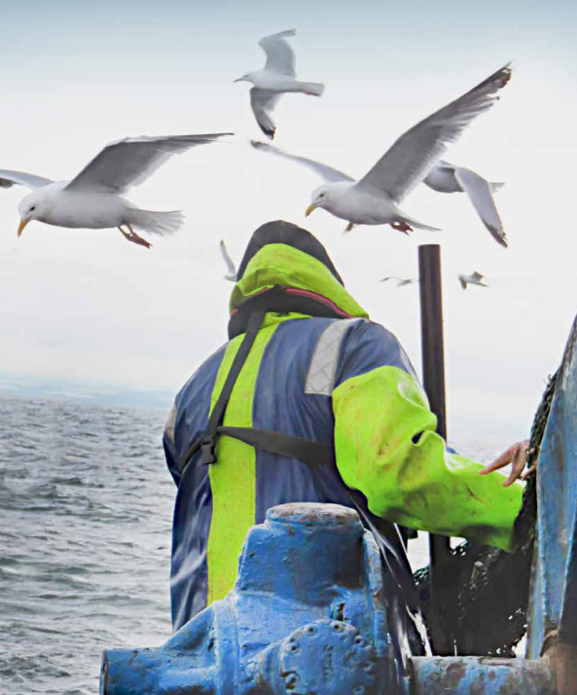

The Fishermen’s Mission
Trustees’
Candidate Information Pack

(Version dated: November 2025)

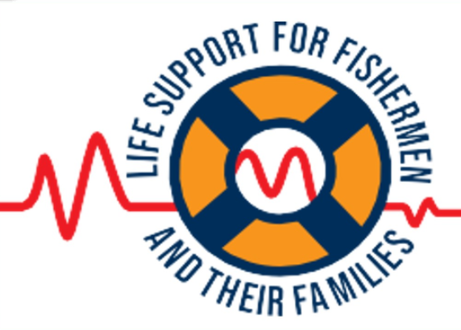

Contents

- Welcome from Mark Greet – Chair of the Council of Management

- About The Fishermen’s Mission
- The role and responsibilities of the Trustee

- Time Commitment, Location, Expenses and Induction/Training
- How to apply

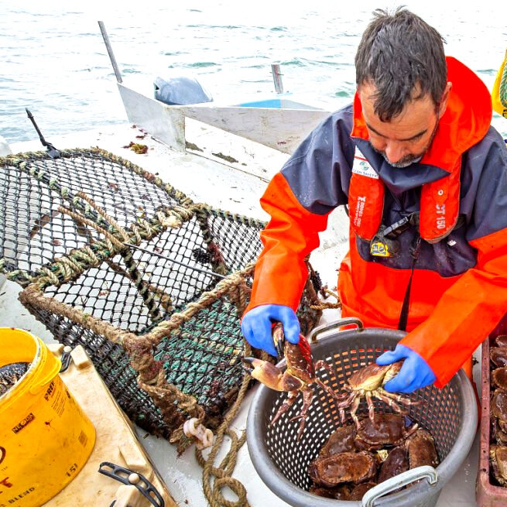
- Welcome from Mark Greet  Chair of the Council of Management of  The Fishermen’s Mission | 

I am delighted that you have expressed an interest in applying to be a Trustee of the Fishermen’s Mission. We hope that you find the information in this candidate brief and on our website useful: https://www.fishermensmission.org.uk/

Commercial fishing remains the most dangerous occupation in the British Isles. The Fishermen’s Mission is the only charity that provides emergency support alongside practical, financial, spiritual and emotional care for fishermen both active and retired and their families.

The Board of Trustees (The Council), consists of up to 15 Trustees and is responsible for the overall direction of the charity and ensuring the Chief Executive and Senior Management Team deliver services efficiently, effectively and legally. We are looking for new trustees with a range of skills and a variety of personal experiences to join us and help bring direction and focus to the vital provision of support to those in our fishing communities.

We are particularly keen to recruit all people with personal experience of the fishing industry and those who may have experienced the work we do. We are also seeking people who have experience in healthcare delivery as well as those with skills in business management and charity governance. As a charity founded on ecumenical Christian principles, we do have a specific intention to fill one position with an ordained Minister. Other trustees need not necessarily be of a Christian faith, but we do seek your agreement to work within an organisation of our nature and foundation and to be aligned with our core traditions and values.

Becoming a Trustee with The Fishermen’s Mission is an exciting and fulfilling opportunity to make a real difference as well as learn new skills.

If this is an opportunity that appeals to you, and you have the skills set out in the job role and key responsibilities section in this candidate brief, we would very much like to hear from you.

To arrange a confidential conversation to find out more please contact Hanna Taylor: hannataylor@fishermensmission.org.uk

Yours sincerely,

Mark Greet
Chair

2. About The Fishermen’s Mission

The Fishermen’s Mission, is a charity run on Christian principles and which supports and welcomes persons of all faiths and none. It is a national maritime welfare charity that supports the fishing communities of the United Kingdom and employs around 70 permanent staff with a presence in over 80 UK ports.

We are the only charity solely dedicated to supporting fishermen and their families (both active and retired) through the provision of emergency support when required alongside more routine practical and financial assistance, including the payment of emergency grants that help to pay bills, buy food and keep house and home together; plus healthcare support and spiritual and emotional care.

Working closely with other maritime partners, the charity’s aim is to relieve despair or deprivation, and through a very active and effective outreach programme, we have a particular focus on actively supporting those who have retired from fishing. We are also increasingly involved in safety, wider well-being and legislative initiatives, working with a range of agencies and industry bodies.

The charity continues to move forward at pace, has delivered against a strategic challenge to improve the quality and range of its activities and is now further developing a series of clear approaches to some key healthcare and well-being issues that are particularly prevalent in our fishing communities.

All development activity is set against the backdrop of the lingering post-coronavirus / Brexit uncertainty and continuing change within the fishing industry. There is also an increasing trend towards professionalisation and legislation of the charitable sector, especially for those charities that are closely involved in the delivery of ‘welfare’ services. The Fishermen’s Mission has responded swiftly to these challenges.

The Fishermen’s Mission is a charity run on Christian principles with a broad ecumenical tradition, particularly amongst the Front-Line staff but one that serves this entire community unconditionally.

Our History

Our story of providing practical help and spiritual support to fishermen began in 1881.  Then the Fishermen’s Mission (officially known as the National Mission to Deep Sea Fishermen) visited ports in a fleet of Mission ships under the banner, “Preach the Word, Heal the Sick” offering food and medical supplies. | 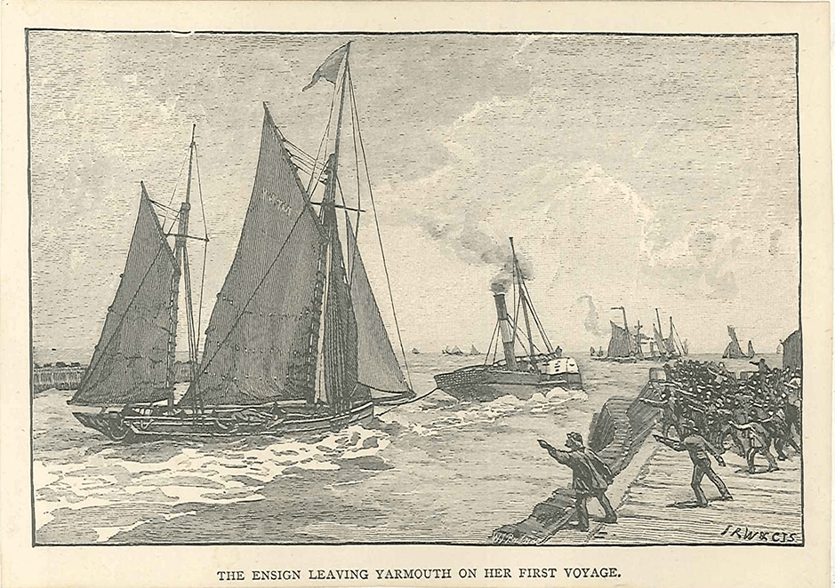
Then we met with fishermen while they worked, trying to alleviate the terrible conditions on board their fishing vessels.
The National Mission to Deep Sea Fishermen was honoured to receive Royal Patronage from Her Majesty Queen Victoria in 1896 making the charity the Royal National Mission to Deep Sea Fishermen (RNMDSF).  Over the course of the next 126 years, we have been privileged to have our Monarch as Royal Patron of the charity and, following the death of Her Majesty Queen Elizabeth II, we were delighted to be informed that our Royal Patronage would continue with Her Royal Highness The Princess Royal. | 

Over the years, the fishing industry has undergone many changes and the Fishermen’s Mission has always responded accordingly.
We went through a phase of establishing large accommodation centres to provide a safe refuge for fishermen to rest for a few hours or stay for a few days when their boats came in, often many miles from their home port. Some of these centres had more than 100 beds. Now, as many fishermen fish from their home ports or have sleeping facilities on board much improved fishing vessels, this requirement has diminished and the large centres closed as the demand changed.
The Fishermen’s Mission then established a smaller number of 24-hour ‘mini-centres’ with good facilities and a small number of welfare offices at key locations around the UK coastline from which the staff work and then spread their net to those slightly further afield.
Our Work Today
Around 12,000 people work in fishing, mostly British but importantly very ably supported by a large number of fishermen from overseas including the Philippines, Sri Lanka, India, Ghana and Nigeria who we will also support while they are working in the UK.
For all, there is no doubt that it remains one of the toughest and most dangerous peacetime occupations. Fishermen sadly face serious and even fatal injury. While the number of fatalities has thankfully much reduced, there remains a very significant number of fishermen who are injured or killed every year simply doing their job.
On land, many individuals and their families struggle with insecurity, uncertainty, and debt. For around 50,000 retired fishermen and their dependants, the fishing may have ended but the hardship often continues as they face debt, scant savings, loneliness, poor health and isolation. The Fishermen’s Mission is there for each and every one of them, helping them through their own personal challenges wherever we can.
The Fishermen’s Mission provides emergency response 24/7, 365 days a year.

This includes:

- Looking after the survivors of fishing emergencies or accidents
- Helping injured or ill fishermen
- Providing emergency assistance to families of fishermen who have been killed or lost at sea
- Meeting the rescue teams and helping with accommodation, food, clothing and contacting families
- Offering emergency grants to fishermen and their families in times of need.
In recent years we have established some very specific initiatives that focus on preventative health and well being.  Working closely with our partners at the Seafarers Hospital Society, we bring services to the quayside based on tide times and fishing seasons. This gives fishermen easier access to health and wellbeing providers to help them make positive lifestyle choices. | 

Our SEAFIT brand is recognised in many fishing ports as we connect fishermen to physical and mental health services.

We conduct regular quayside conversations, NHS health checks, mental health counselling, dental check-ups, health screening, information on self-management of long-term conditions, cancer information and a newly developed physiotherapy network. We also work with local GPs, health professionals and other charitable organisations.

Over the past couple of years, we have worked in partnership with Macmillan Cancer Support to raise awareness and knowledge of cancer among fishermen and the wider fishing community.  We discuss the risks, symptoms, screening, treatment and aftercare with the people who need to know.  We seek to normalise the conversation about cancer across fishing communities through education and signposting people to relevant cancer health and community services. | 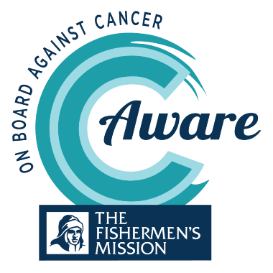  

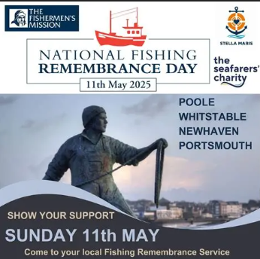 | Today, working closely with our partners in the maritime welfare sector, we lead the coordination and delivery of National Fishing Remembrance Day services held all around the country each May, bring the community together to remember those who have been lost in pursuit of the catch. | 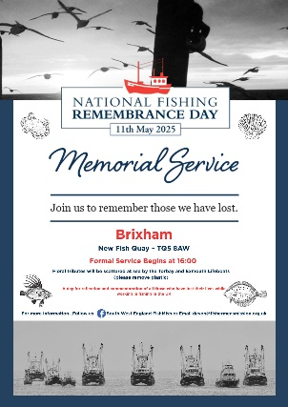

Today, the charity has an annual turnover of about £3m and despite significant economic challenges in the UK, the charity has remained well-set, managing a very sizeable reserves portfolio which along with our other income, ensures we can resource our continuing and planned work.

That said, it is always very reassuring when our auditors declare each year that we remain a ‘going concern’, operating on a solid financial and management footing.

Our latest Trustees’ Annual Report, financial statements and Impact Report are available to view here: Reviews and Reports - Fishermen's Mission.

 | 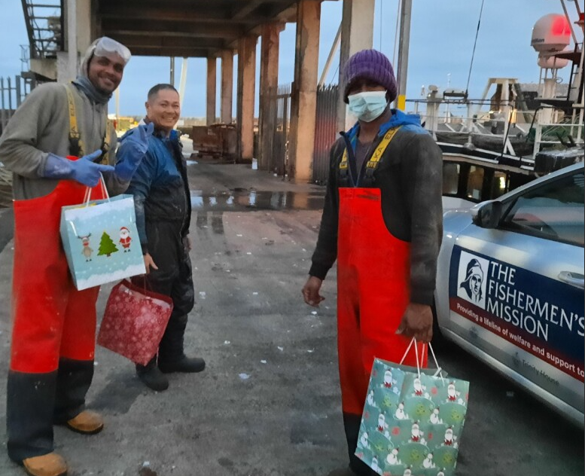 | 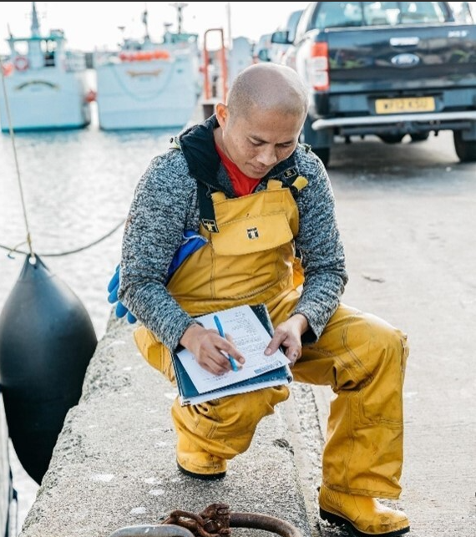

3. The Role and Responsibilities of the Trustee

The Fishermen’s Mission is an incorporated charity, meaning it is a registered charity and a Company Limited by Guarantee. The charity is directed by a Board known as the Council of Management (or ‘Council’) consisting of up to 15 Trustees.

Trustees are also company directors and are responsible for the overall direction of the charity, the general control and management of the administration of a charity and to ensure that the Chief Executive and Senior Management Team delivers the charity’s services efficiently, effectively and legally.

Our Trustees have a variety of backgrounds and skills. The Fishermen’s Mission is ever keen to increase the diversity of the current board and is looking for potential Trustees with a range of skills and who come from differing walks of life each with their own unique life experiences to help bring direction and focus to the delivery of vital provision in fishing communities.

Main responsibilities of Trustees. There are six main responsibilities of a Trustee:

- Ensure the charity is conducting its purposes for the public benefit.
- Compliance with the Charity’s governing document and the law.
- Act in the charity’s best interests.
- Manage the charity’s resources responsibly.
- Act with reasonable care and skill.
- Ensure the charity is accountable.

Trustees must have and accept ultimate responsibility for directing the affairs of The Fishermen’s Mission, ensuring effective and efficient administration, including having appropriate policies and procedures in place and holding the Chief Executive to account when necessary.

Trustees must ensure that the charity pursues its stated charitable objects, in compliance with the Articles of Association, establishing a clearly defined vision, set of values and strategy, ensuring that there is a common understanding of these by trustees, staff and associated personnel and evaluating output performance against agreed targets.

Trustees must ensure there are regular reviews of the environment in which the charity operates, identifying changes that might affect the way the charity operates - political, financial, demographic, competitive, partnerships, alliances.

Management of Resources. It is a Trustee’s legal duty to responsibly manage the resources and ensure the financial stability and solvency of The Fishermen’s Mission, including the proper investment of its funds.

Trustees must ensure that operational plans and budgets support the vision and strategy, that resources are consumed exclusively in pursuance of its charitable objects and that appropriate financial controls are implemented, and risks managed.

Personal conduct . It is a Trustee’s legal duty to act with reasonable care, skill and prudence in all matters relating to The Fishermen’s Mission. Trustees must always exercise a proper degree of care in administering the charity, seeking and taking appropriate advice, as necessary.

Trustees must always bear in mind that their prime concern is the interests of the charity and must not let any personal views, prejudices or actions affect their conduct as a trustee or adversely impact upon the reputation and values of The Fishermen’s Mission which it is their duty to uphold.

Trustees will commit to Nolan’s seven principles of public life, namely: selflessness, integrity, objectivity, accountability, openness, honesty and leadership.

Conflict of interest . It is also a Trustee’s legal duty to act in the best interests of The Fishermen’s Mission. Where trustees are required to make a decision that affects the personal interests of one or more of the trustees, the charity's governing document may require that those persons should not be present at any discussion or vote on the matter.

Minimum age. Trustees must be at least 16 years old.

Disqualification. You must not act as a trustee if you are disqualified under the Charities Act unless your disqualification has been waived by the Commission.

Fit and proper persons. The Fishermen’s Mission is entitled to claim UK tax relief and exemptions e.g. Gift Aid. Trustees must therefore meet the management condition in the Finance Act 2010 which requires all the charity’s managers, including trustees, to be ‘fit and proper persons’.

Disclosure and Barring Service (DBS) checks. The Fishermen’s Mission will conduct appropriate DBS checks prior to appointment.

Personal Qualities. Trustees of the Fishermen’s Mission will be committed to the values and goals of the charity including a commitment to equal opportunities and the active promotion of diversity across the charity. Trustees will be willing to devote the necessary time and effort to the role. They are expected to exercise independent, strategic thinking and good judgement; speak openly; challenge appropriately (“critical friend”); support and advocate willingly as part of a unified team.

Professional skills. Trustees will be recruited to provide Council with knowledge and experience across a wide range of areas including: the fishing industry; maritime safety; charity/corporate law & governance; fund-raising; leadership & management; financial management; healthcare, welfare and well-being; marketing, media and public relations.

Getting the right mix of people and skills helps to satisfy the key duties of all trustees, described by the Charity Commission for England and Wales in ‘The Essential Trustee’:

The essential trustee: what you need to know, what you need to do - GOV.UK
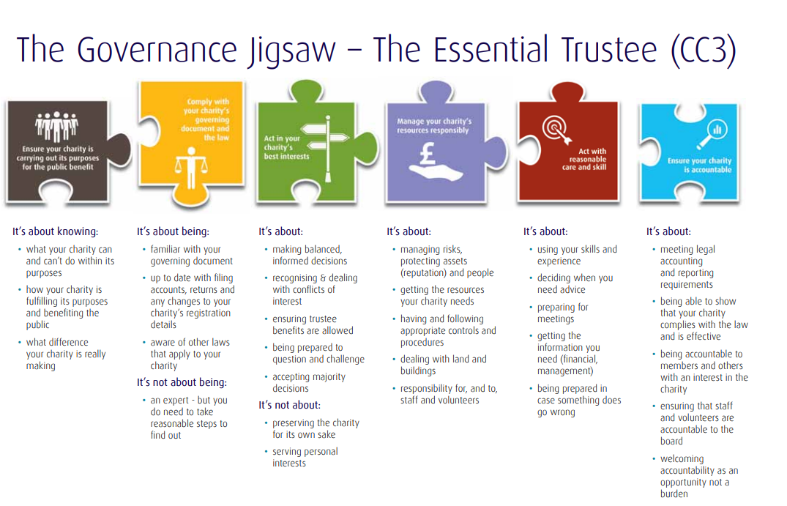

The most important thing for us is creating a board of Trustees that can not only deliver in terms of the ‘governance jigsaw’ but who can truly help with giving direction on what is truly important on the ground for those fishermen, former fishermen and their families who look to us for help in their time of need.

To this end we really do want to recruit a well-balanced and diverse board and this means that it is not essential to have previous ‘board’ experience; but it is essential to be able to help the board understand what should be its focus.

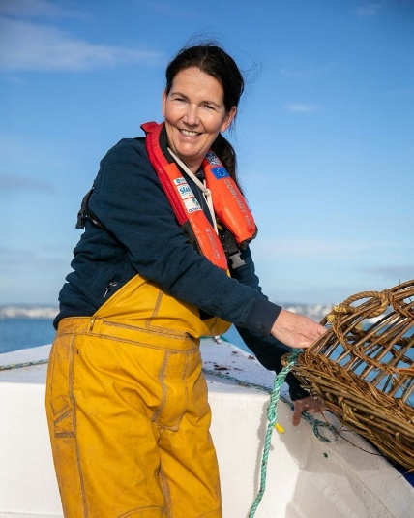 | 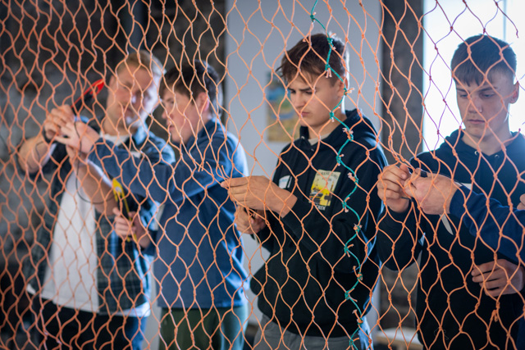  The Young Fishermen Network UK

4. Time Commitment, Location, Expenses and Induction/Training

Time commitment. Council meets four times a year: twice ‘in person’ during the day and usually in London, and twice online. One sub-committee meets three times yearly and two others meet twice yearly (sub-committee business is also conducted online). The Council also seeks to meet once annually for an in-person ‘away day’ (afternoon session / overnight stay / morning session / disperse).

Location. The charity’s Head Office is based in Whiteley, Hampshire.

Expenses. Trustees are all volunteers. The position is unremunerated but reasonable out of pocket expenses for travel etc will be covered in accordance with the charity’s current Trustees’ Expenses Policy.

Induction/Training. An induction and training programme is provided. New Trustees will be ‘buddied-up’ with a longer serving Trustee who will act as a mentor.

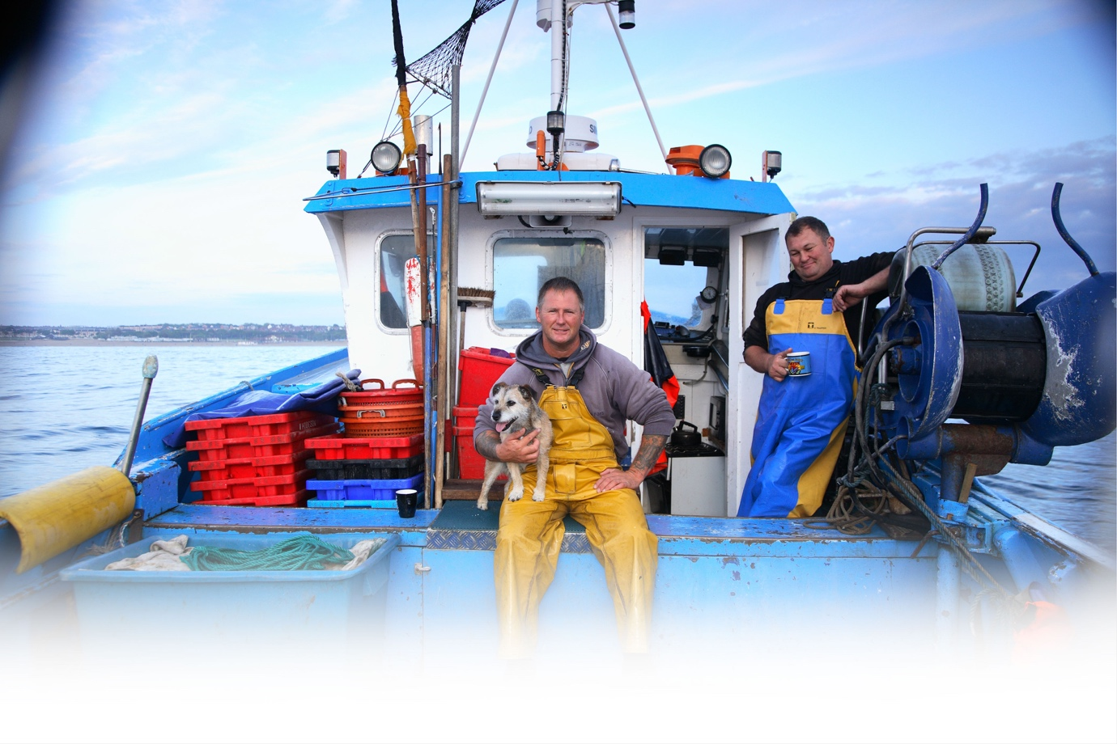
5. How to apply

How to Apply. In the first instance, it is strongly recommended that interested parties arrange an initial conversation with the Chief Executive, Marc Evans or the Governance Professional, Hanna Taylor:
Email: marcevans@fishermensmission.org.uk | hannataylor@fishermensmission.org.uk
Thereafter, you will be invited to apply by submitting:
- A comprehensive CV and;
- A covering letter that contains:
- A personal statement which fully addresses the criteria listed in the role and responsibilities section.
- Answers to the following questions, illustrating your responses with examples or evidence from your own life experiences – these could be from your working, volunteering, community, or personal life:
  - Why are you interested in joining The Fishermen’s Mission specifically? (not more than 300 words)
  - What knowledge, skills and experience have you gained in your life that you would bring to our Council? (not more than 500 words)
  - How could you make a difference to The Fishermen’s Mission? (not more than 200 words)
- Your acknowledgement of and availability for the time commitment required and outlined in this brief.
- The name, job title, organisation, email address and mobile number of two professional referees. Please note referees will not be approached without your prior permission.
Please ensure that you include your mobile phone number and email address in your application.
All applications will be assessed against the criteria in the Role & Responsibilities section.
Candidates who best meet the criteria will be invited to an online interview and then, potentially, and in person interview.
Candidates will be advised of the progress of their application throughout the process by email.

If you would prefer to receive this candidate brief in a more accessible format, please contact us and advise how we can help you.

